MOBILE APP DEVELOPMENT REPORT

Made by – Anika Samvedi & Victor Dubrana

**Introduction**

Invest.er is a mobile application designed to bridge the gap between startup founders and investors. The platform offers a smart, user-friendly interface to facilitate networking, collaboration, and investment opportunities. This report provides an overview of the project, its objectives, architecture, features, and the challenges encountered during its development.

**Objectives**

* **Primary Goal:** Create a secure and efficient platform for founders and investors to connect and collaborate.
* Simplify the process of finding relevant opportunities for both parties.
* Provide real-time communication and notifications to enhance engagement.

**Problem Statement**

Startup founders often face challenges in finding the right investors to fund their ventures, while investors struggle to identify promising startups. There is a need for a streamlined, scalable, and secure platform to bridge this gap.

**Solution Overview**

Invest.er provides:

1. A secure authentication system for user access.
2. Smart matching algorithms to pair founders with relevant investors.
3. Real-time communication through a robust chat feature.
4. A user-friendly interface for seamless navigation and engagement.
5. Scalable backend architecture to handle growing user demands.

**Target Audience**

* **Founders:** Startups seeking funding and mentorship.
* **Investors:** Angel investors and venture capitalists looking for potential investment opportunities.

**Key Features**

1. **User Authentication:** Secure sign-in via Firebase Authentication (Google/Email).
2. **User Profiles:** Tailored profiles for founders and investors.
3. **Matching Algorithm:** Smart recommendations based on user preferences and profiles.
4. **Real-Time Messaging:** Chat functionality with notifications.
5. **Favorites List:** Users can save and revisit profiles of interest.
6. **Responsive Design:** Optimized layouts for various screen sizes.
7. **Cloud Backend:** Firebase Firestore for real-time and scalable data storage.

**App Architecture**

The app follows a modular and scalable architecture:

1. **Frontend:** Built with Jetpack Compose (Kotlin) for modern, declarative UI.
2. **Backend:** Firebase Firestore for real-time database and Firebase Cloud Messaging for notifications.
3. **Authentication:** Firebase Authentication for secure user login.
4. **Navigation:** Jetpack Navigation Component for smooth transitions between screens.

**User Flow**

1. **Login/Sign-Up:** Users sign in securely using Google or email.
2. **Profile Setup:** Founders and investors complete their profiles.
3. **Home Screen:** Smart recommendations displayed.
4. **Favorites & Projects:** Users save profiles or create projects.
5. **Messaging:** Real-time chat to connect and collaborate.
6. **Logout:** Users can securely log out of their accounts.

**Above are some screenshots of application we can see**

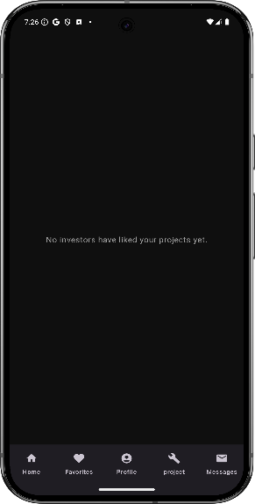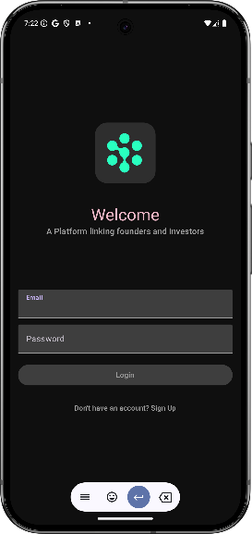 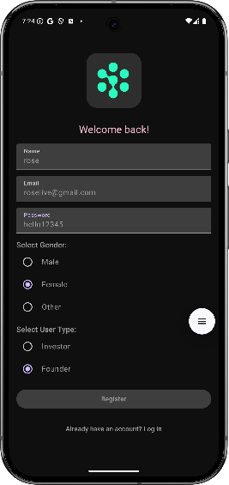

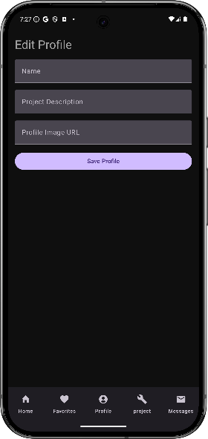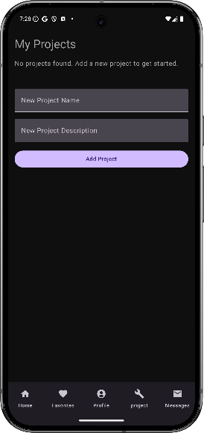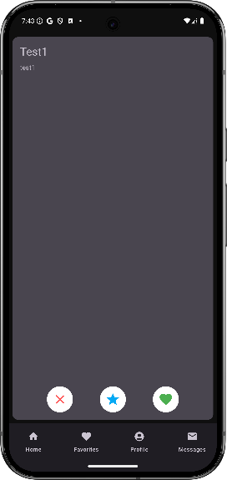**Tech Stack**

1. **Programming Language:** Kotlin
2. **UI Framework:** Jetpack Compose
3. **Backend:** Firebase Firestore, Firebase Authentication
4. **Real-Time Messaging:** Firebase Realtime Database
5. **Notifications:** Firebase Cloud Messaging
6. **Version Control:** Git and GitHub
7. **Build Tool:** Gradle

**Challenges and Solutions**

**Challenges:**

1. **User Authentication and Data Security:** Ensuring secure authentication and data handling.
2. **Real-Time Messaging:** Implementing seamless chat functionality.
3. **Matching Algorithm:** Designing an efficient and scalable recommendation system.
4. **Cross-Platform Compatibility:** Ensuring responsiveness on different devices.

**Solutions:**

1. Leveraged Firebase Authentication for secure user access.
2. Integrated Firebase Realtime Database for instant chat and notifications.
3. Utilized Firebase Firestore queries for smart matching.
4. Designed adaptive UI with Jetpack Compose.

**Future Enhancements**

1. **AI-Driven Recommendations:** Incorporate AI to enhance matchmaking efficiency.
2. **In-App Video Calls:** Enable video meetings between founders and investors.
3. **Analytics Dashboard:** Provide users with insights and analytics.
4. **Multi-Language Support:** Expand accessibility for global users.

**Conclusion**

Invest.er serves as a comprehensive platform for fostering collaboration between startup founders and investors. By leveraging modern technologies like Firebase and Jetpack Compose, the app ensures a secure, scalable, and user-friendly experience. The project's success demonstrates its potential to address real-world challenges in the startup ecosystem.

**Project GITHUB LINK: https://github.com/rookiky/Invest_er.git**